

**MINI PROJECT Semester 3(2021-2022)**

**Topic –** **Student Record Maintenance System**



**Name – Aditya Bahl**

**Project Guide** - **Mr.Pankaj Kumar**

**HOD** -**Devesh Pratap Singh**

**University Roll No. – 2016580**

**Semester – 3**

**Section –B**

**Class Roll No. – 25**

**DECLARATION**

I, **Aditya Bahl** student of **B-tech, Semester 3**, Department of Computer Science and Engineering, Graphic Era Deemed University, Dehradun, declare that the technical project work entitled “**Student Record Maintenance System**” has been carried out by me and submitted in partial fulfillment of the course requirements for the award of degree in B.Tech of Graphic Era Deemed University during the academic year **2021-2022.** The matter embodied in this synopsis has not been submitted to any other university or institution for the award of any other degree or diploma.

**Date: 26/02/21**



***CERTIFICATE***

This is to certify that the project report entitled “**Student Record Maintenance System**” is a bonafide project work carried out by Priyank Choudhary , roll no- 2014783. in partial fulfillment of award of degree of B.Tech of Graphic Era Deemed University, Dehradun during the academic year 2021-2022. It is certified that all corrections/suggestions indicated for internal assessment have been incorporated. The project has been approved as it satisfies the academic requirements

associated with the degree mentioned.

**Dr. Devesh Pratap Singh**

**HOD ( Computer Science)**

**PROBLEM STATEMENT –**

A Student Records Maintenance System is a software developed for daily student attendance in schools, colleges and institutes. It facilitates information of students in an organisation. This system will also help in displaying and deleting information of a student.

**BRIEF MOTIVATION –**

Student Record Maintenance Systems can be used by education institutions to maintain the records of students efficiently and in unprecedented quantities in a more secure and approachable method, ensuring data transparency as well as encapsulation of the data. Achieving this objective is difficult using a manual system as the information is scattered and redundant moreover collecting the relevant information may be a hectic process if not automated and time consuming which would prohibit the faculties from having the time required for an efficient learning. This is where my mini-project Academia comes into play.

**Project Introduction -**

Academia aims to provide the necessary tools to the teachers of an institution to better manage and execute the ever expanding databases of the students.

There are **four** major components of this project -

1. Creation of records.
2. Storage of records.
3. Display of records.
4. Deletion of records.

**Tools Used -**

1. **PHP** - For Structuring and connecting SQL based server to the web application.
2. **SQL** - Used for creation, maintenance, storage and deletion of the database.
3. **HTML** - Used for the texts and medias in the website.
4. **Java Script**  - Used in various components, primarily in form of the bootstraps components(for eg- the Navbars).
5. **CSS** - Used Similarly like java script.
6. **Bootstraps** - For visual components.
7. **VS Code** - For Writing codes.
8. **XAMPP** - For connecting the codes to the database.

**Methodologies Followed** -

1. ) **A Custom Logo** - Rather than using stock logos which do not offer the sense of vision and direction, our logo is hand crafted and custom built, offering a more personalized connection with the customer.



1. ) **Login Page** - to only allows users registered with the proper User ID and Password.

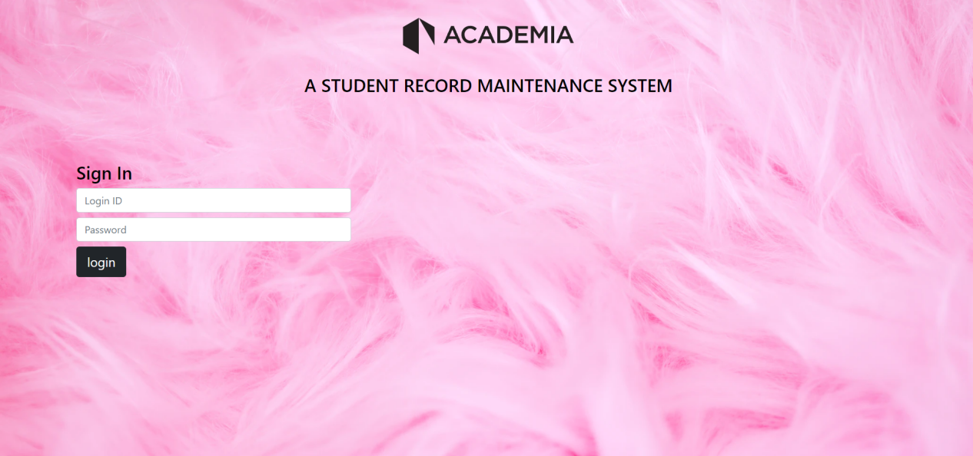

3.) **Home Page -** Images dynamically showcasing the project and its back-end in carousel mode with timed transitions and control features and in brief along with Team Academia’s Goals and Vision for a more future based and effective learning environment in educational institutions.

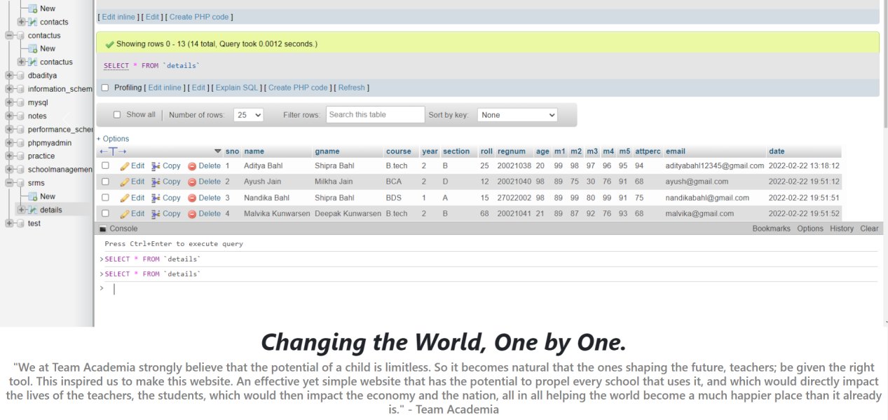

4.) **Add Details** **Page** -

**A) Name of the Database -** srms

**B) Details Added** -

i.) S.No

ii.) Name

iii.) Guardian’s Name

iv.) Course

v.) Year

vi.) Section

vii.) Roll

viii.) Registration Number

ix.) Age

x.) Subject Marks 1

xi.) Subject Marks 2

xii.) Subject Marks 3

xiii.) Subject Marks 4

xiv.) Subject Marks 5

xv.) Attendance Percentage

xvi.) Email

Xvii.) Date

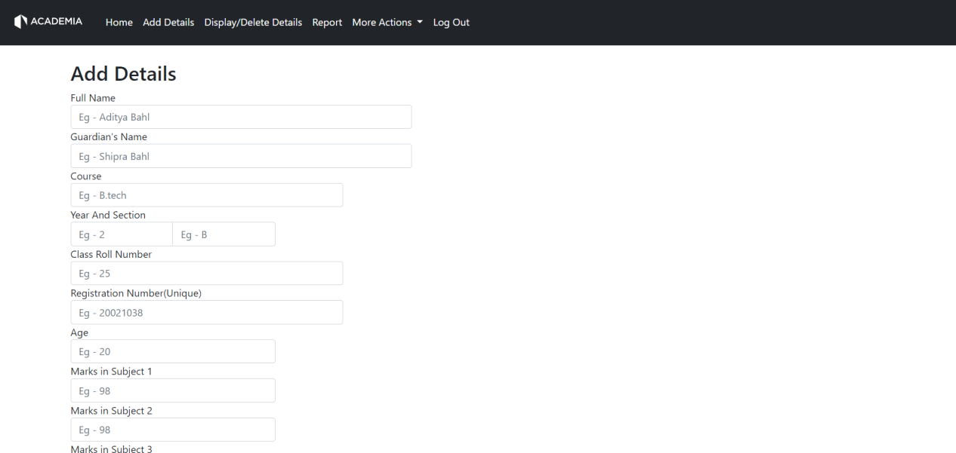

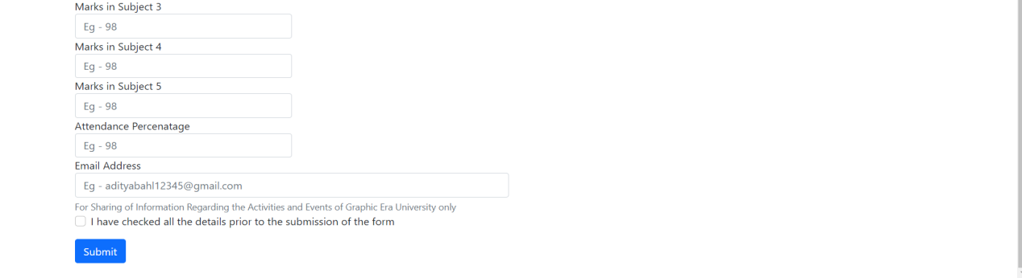

1. ) **Displaying Details -**
2. **Sorted View -** applied in all classes of details in ascending or descending order.
3. **Search Bar -** Search any keyword or reference to the information.

*(for example, if someone wanted to search for Aditya, they can just search Adi and every information with Adi in it will be displayed, no matter which class of information is stored in it.)*

1. **Option to View Information in various packets -** For example it has options of viewing 10,25,50 or 100 records per page.
2. **Marks Percentage** - The marks inputted for the 5 subjects in various records will be calculated and displayed as the overall marks percentage.
3. **Various Number of Pages** - According to the number of Records Inserted, provided with a next and previous button too, for a seamless way to transition from a set of records to the another.

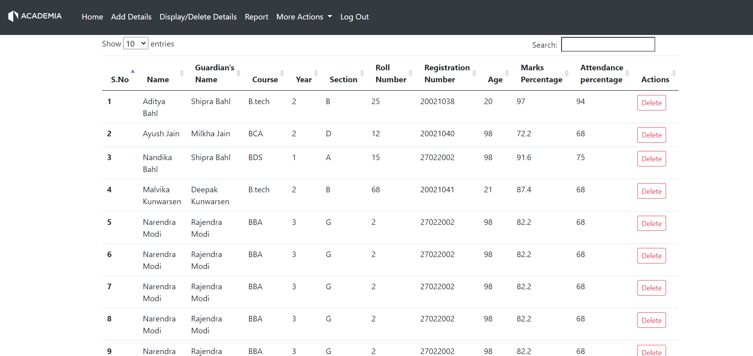

1. ) **Deletion of Details -** Information deletion from the Database.

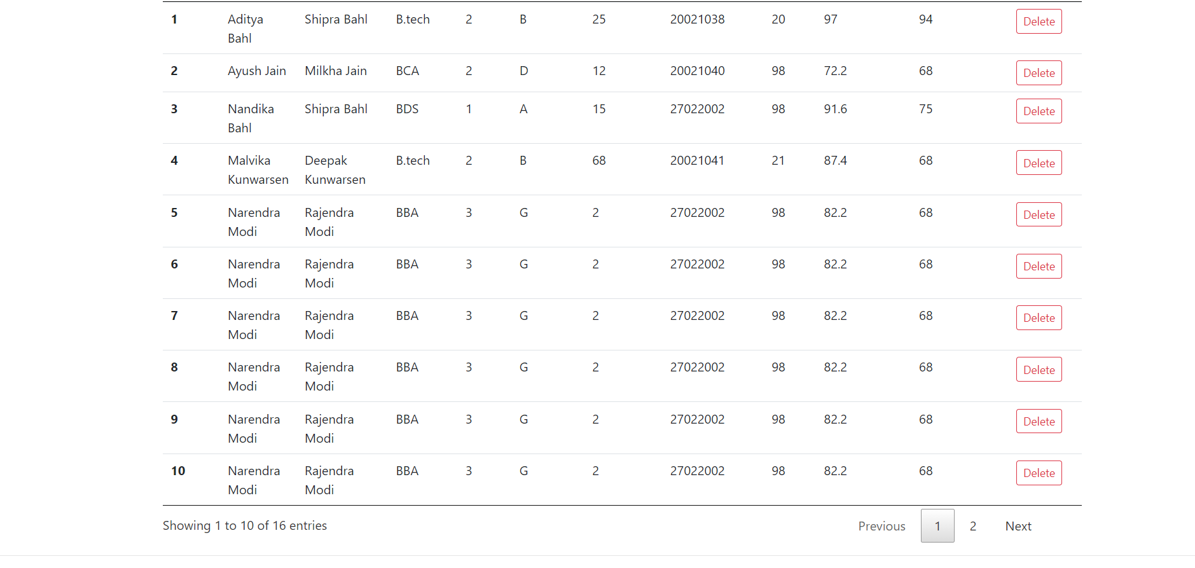

5.) **Report Button -** allows the user to see the report(this document) of the project, directly with this button.

6.) **About Us Page -** gives information about Team Academia along with a surprise feature.

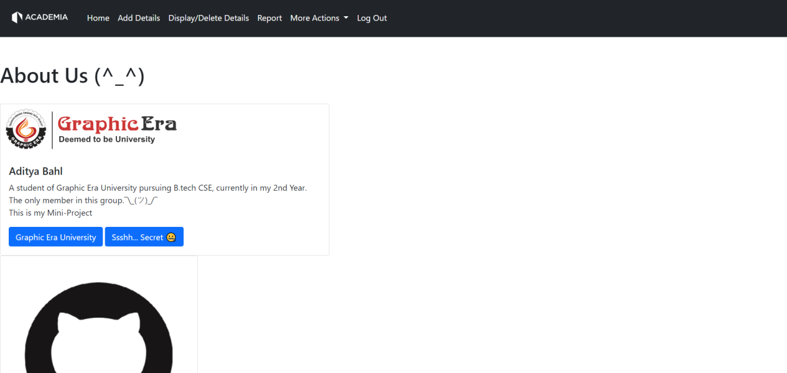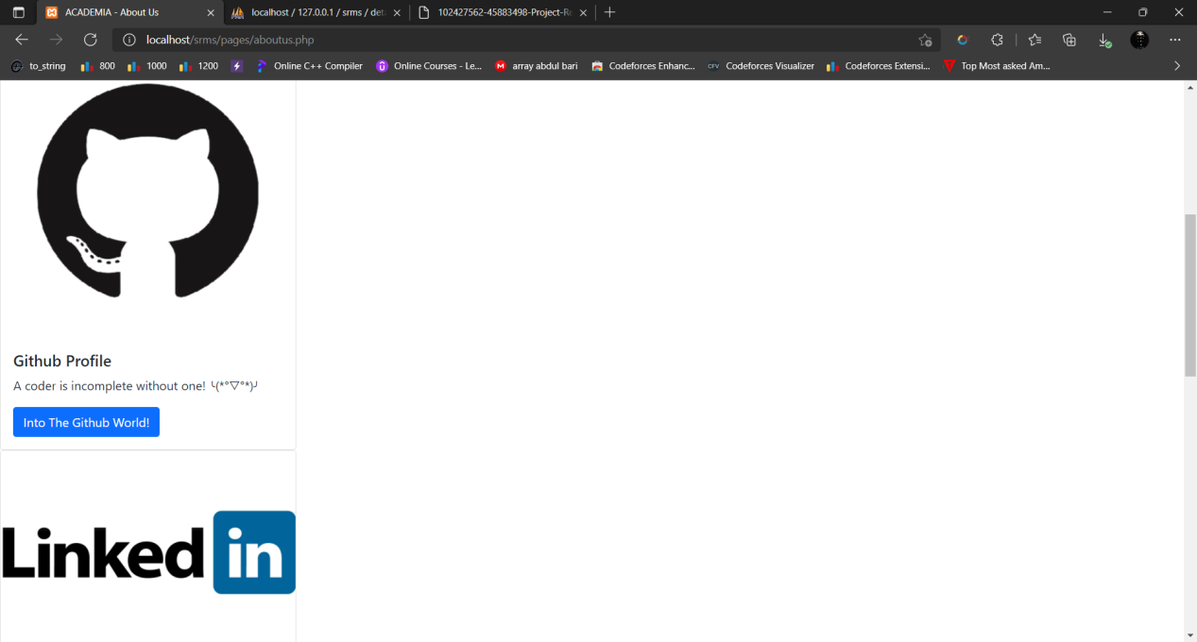

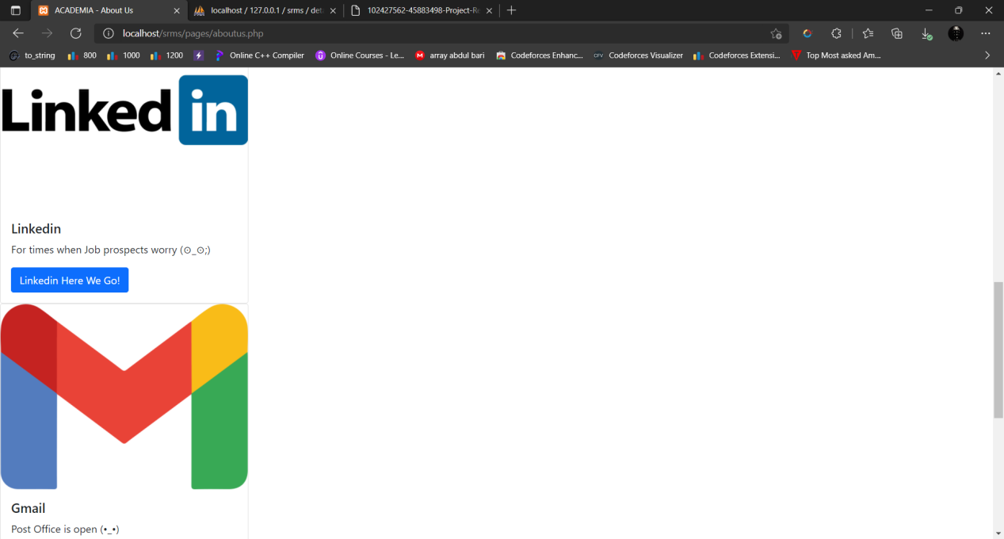

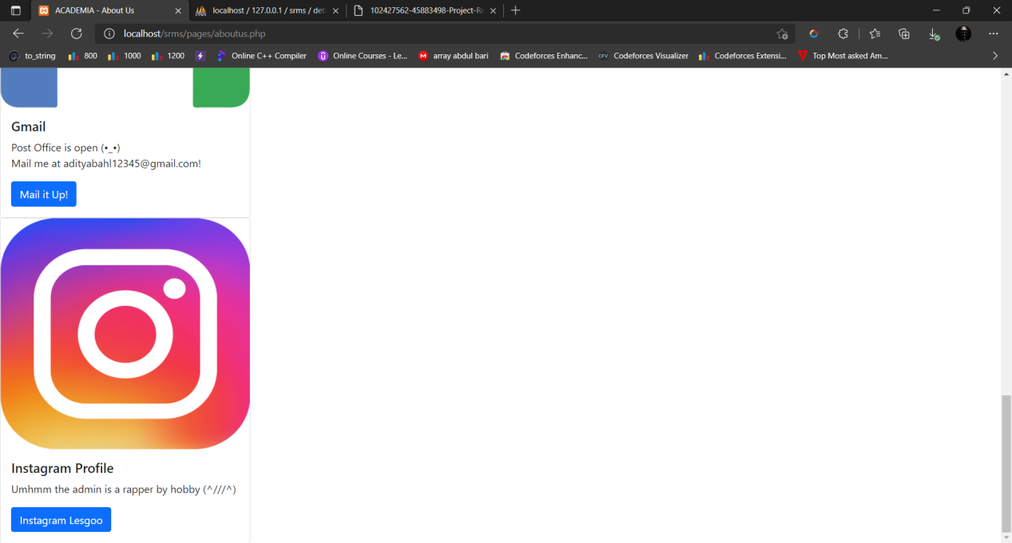

1. ) **Contact Us Page** - Allows the user to feed in his or her details namely name and email which is stored in a different database, which can then be used by the administrator to get in touch with them, for sharing of any relevant information.

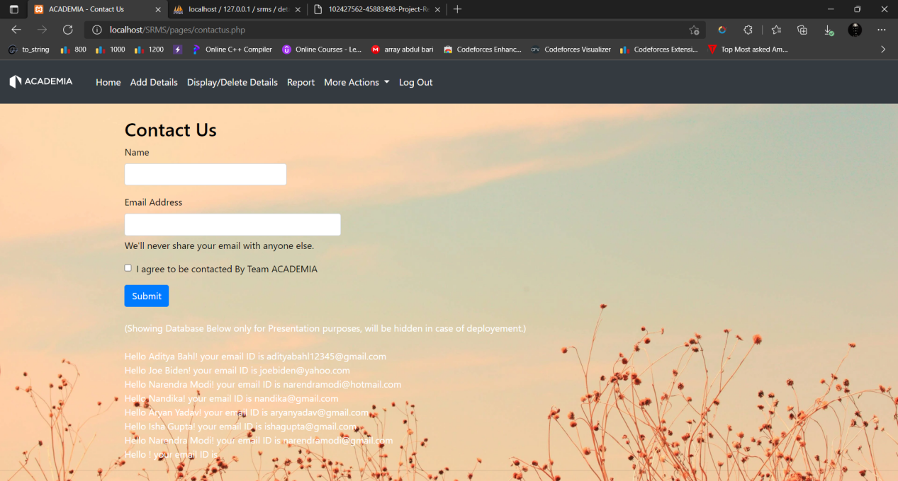

1. ) **Suggestions** - Allows the user to feed in his or her details namely name, email and suggestions which is stored in a different database, which can then be used by the administrator to follow up with the person suggesting any changes, or simply view the suggestions.

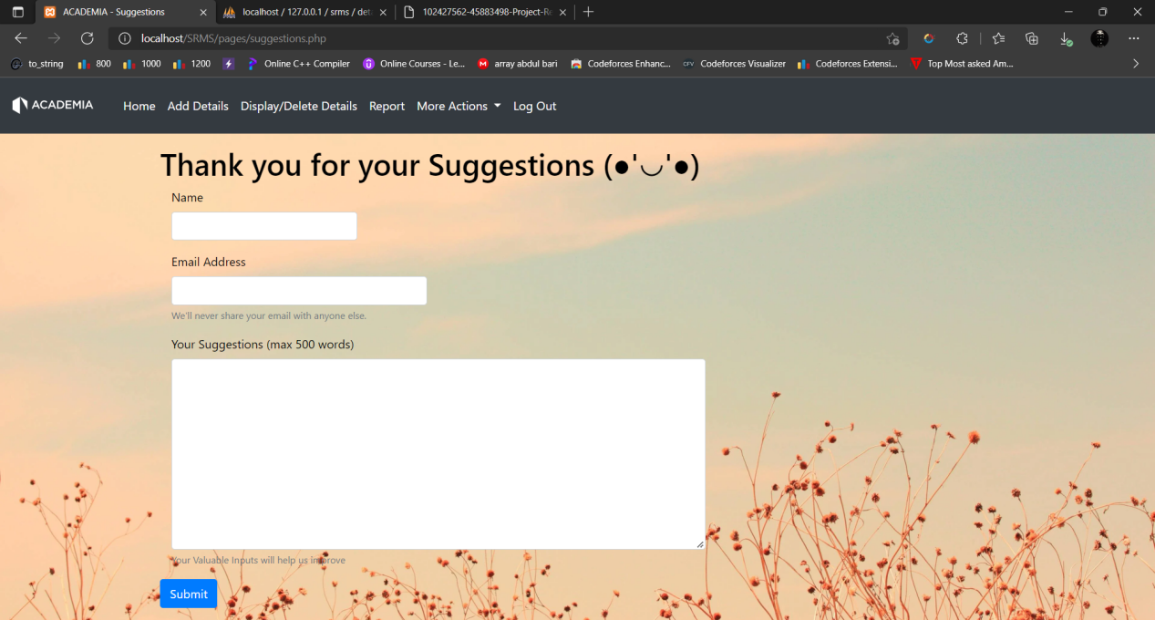

9.) **Log Out** - Logs out the user out of the Website.

10.) **DATABASE -**

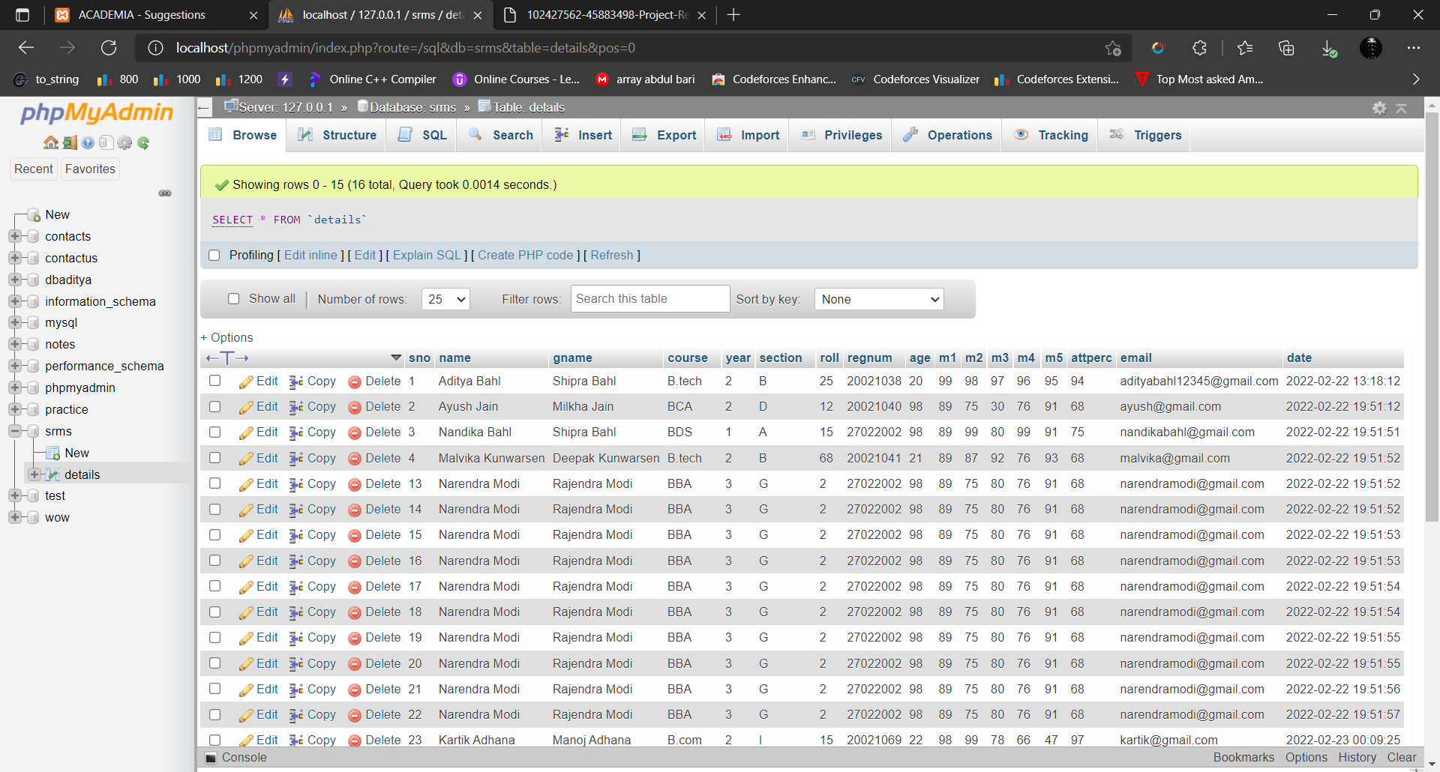

**References -**

1. **Code With Harry playlist on PHP and mysql on YouTube** - [PHP Tutorials in Hindi - YouTube](https://www.youtube.com/playlist?list=PLu0W_9lII9aikXkRE0WxDt1vozo3hnmtR)
2. **Bootstraps** - [Introduction · Bootstrap v5.1 (getbootstrap.com)](https://getbootstrap.com/docs/5.1/getting-started/introduction/)
3. **Stack Overflow** - [Stack Overflow - Where Developers Learn, Share, & Build Careers](https://stackoverflow.com/)